Esegui questa moltiplicazione, 12 x 14, sia con il diagramma rettangolo, che con il diagramma “gelosia”

|  |  |  |
| --- | --- | --- |
| 1 |  | 2 |

|  |
| --- |
| 1 |

|  |
| --- |
| 12 |

|  |  |
| --- | --- |
| Scrivi il risultato della  moltiplicazione con il diagramma rettangolo | Scrivi il risultato della  moltiplicazione con il diagramma “gelosia” |
|  |  |

|  |
| --- |
| 14 |

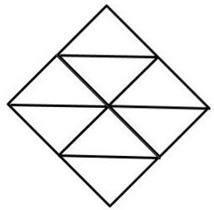

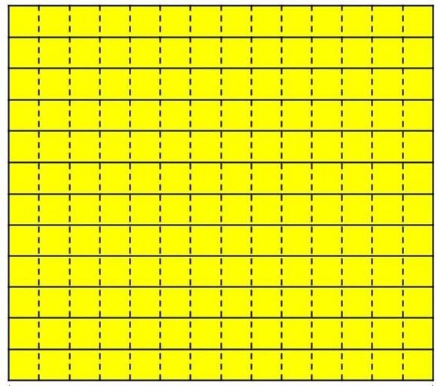

|  |
| --- |
| 4 |

Che cosa noti?

__________________________________________________________________________________________________________________________________ __________________________________________________________________________________________________________________________________ __________________________________________________________________________________________________________________________________ __________________________________________________________________________________________________________________________________ __________________________________________________________________________________________________________________________________

__________________________________________________________________________________________________________________________________

Prova a spiegare il perché, secondo te

__________________________________________________________________________________________________________________________________ __________________________________________________________________________________________________________________________________ __________________________________________________________________________________________________________________________________ __________________________________________________________________________________________________________________________________

__________________________________________________________________________________________________________________________________

__________________________________________________________________________________________________________________________________